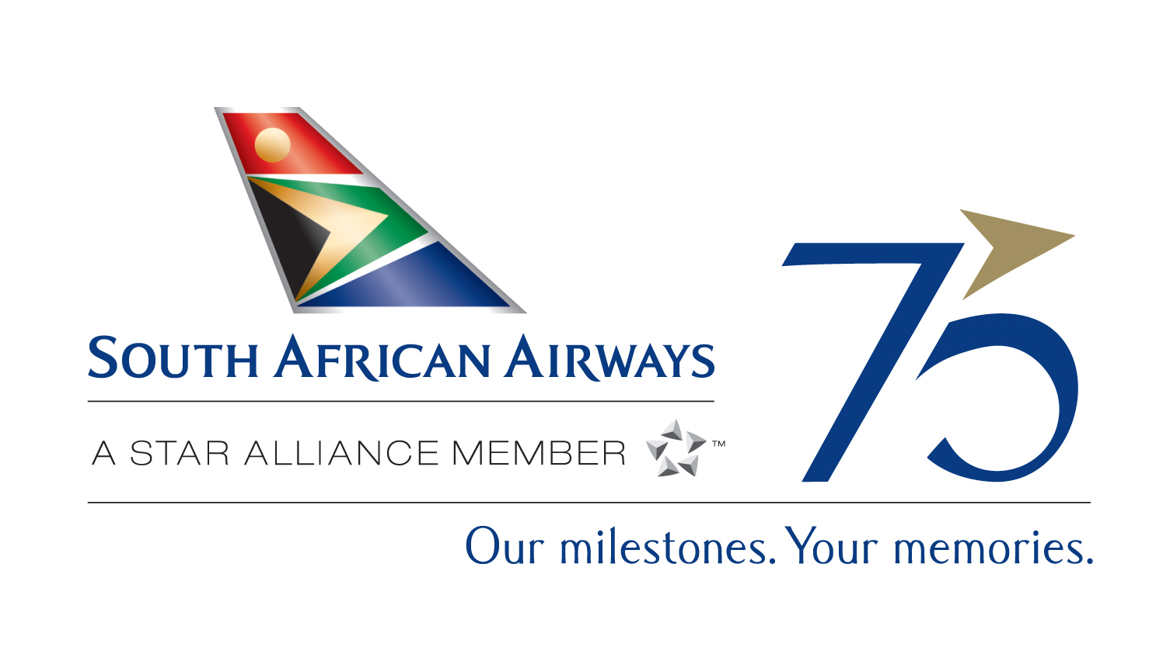

Contact: Elizabeth Ninomiya, South African Airways; Tel: 954-769-5120
elizabethninomiya@flysaa.com

BACKGROUNDER

SOUTH AFRICAN AIRWAYS: WORLD-CLASS SERVICE

AND COMFORT GARNER AWARD-WINNING ACCLAIM

South African Airways has long been recognized for its exceptional level of comfort and in-flight service, and its roster of awards over the years from international publications, including “Best Business Class,” makes its mission quite clear -- to provide unrivaled service excellence to each passenger, on each flight. The following is a list of some of the honors bestowed upon South African Airways in the last two years alone:

- Voted “Best Airline to Africa” for the 11th time – Business Traveler Magazine (2008)

- Voted “Best Airline to Africa” for the 5th consecutive year – Global Traveler Magazine (2008)

- Winner of “”Best Airline in Africa” and “Best Cabin Crew in Africa” – Skytrax World Airline Awards (2008)

- Winner of “Best Airline to Africa” – Weekly Globe Awards (2008)

- Winner of “Best Airline to Africa” – Executive Travel Magazine Leading Edge Awards (2008)

- Winner of “Best Airline Based in Africa” – 26th OAG Airline Industry Awards (2008)

- Winner of “Africa’s Leading Airline” – World Travel Awards Africa Ceremony (2008)

- Winner of “Airline of the Year” – CBC African Business Awards (2008)

- Winner of “Best in Africa” and “Best Cabin Crew” – Skytrax Best in Region Awards (2007)

- Voted “Best Airline to Africa” for the 10th time – Business Traveler Magazine (2007)

- Voted “Best Airline to Africa” for the 4th consecutive year – Global Traveler Magazine (2007)

- Winner “Best Airline Based in Africa” – OAG (2007)

- Winner of “Best Scheduled Airline to Africa” – Weekly Globe Awards (2007)

- Winner of “Best African Airline” – ASATA (2007)

- Voted “Africa’s Leading Airline,” “Africa’s Leading Business Class Airline,” “Africa’s Leading First Class Airline,” and “Africa’s Leading Airline Website” – 14th World Travel Awards (2007)

South African Airways features the only nonstop service from the U.S. to South Africa with daily departures from Washington, D.C. (until April 30^{th,} with a stop in Dakar commencing May 1), and daily direct service from New York (operating non stop effective May 1) that offer travel convenience and award-winning service. Travelers in premium class enjoy 180° fully flat-bed seats, and in economy class enjoy the most legroom versus competitors. Every seat on board offers an individual on-demand entertainment system, plush pillow, warm blanket and amenity kit. SAA’s unrivaled network, featuring seamless connections to more than 20 destinations within South Africa, and more than 20 cities across the rest of the continent, makes the airline the savvy traveler’s “gateway to Africa.” As a Star Alliance member, South African Airways is able to offer its customers 912 destinations in 159 countries and more than 16,500 flights daily, including convenient connections from more than 25 cities in the U.S. through code share service with Star Alliance member United Airlines. Members of United’s Mileage Plus, US Airways’ Dividend Miles and Air Canada’s Aeroplan programs are able to earn and redeem miles on all SAA flights. For more information on South African Airways, please call (800) 722-9675 or visit www.flysaa.com, where travelers can sign up to be notified of other great travel deals and vacation packages.

# # #
Updated January 2009

